**IP Tester Web**

**Instruction**

1. **Configuration and access**
2. Browser

IP tester web relies on the serial port function in Chrome. The development is also based on Chrome (96.0.4664.45). In order to make sure all the function of the IP tester web is working, please use a newer Chrome version.

1. Browser Setting

please do the following setting before you start.

/*****Enable sites to automatically download multiple files*****/

Settings-Privacy and security-Site Settings-Additional permissions-Automatic downloads- Add-Copy the links for the IP tester 1.0 and paste here.

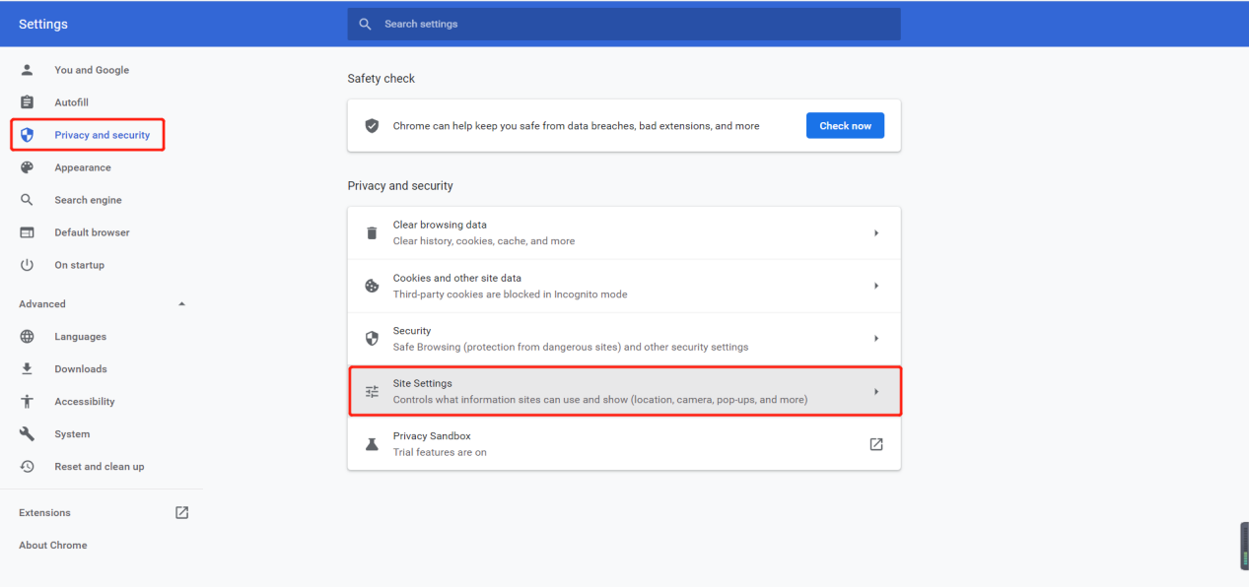

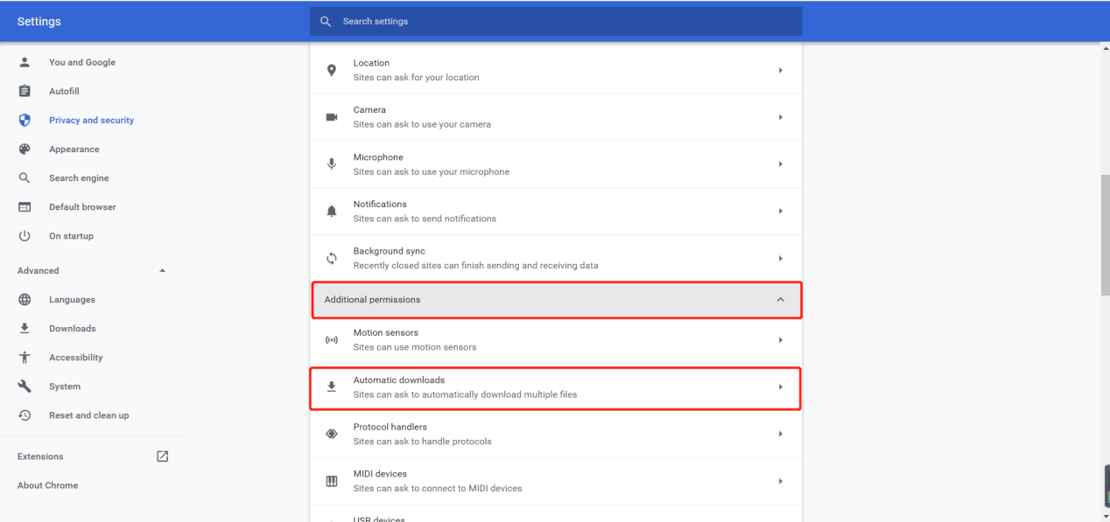

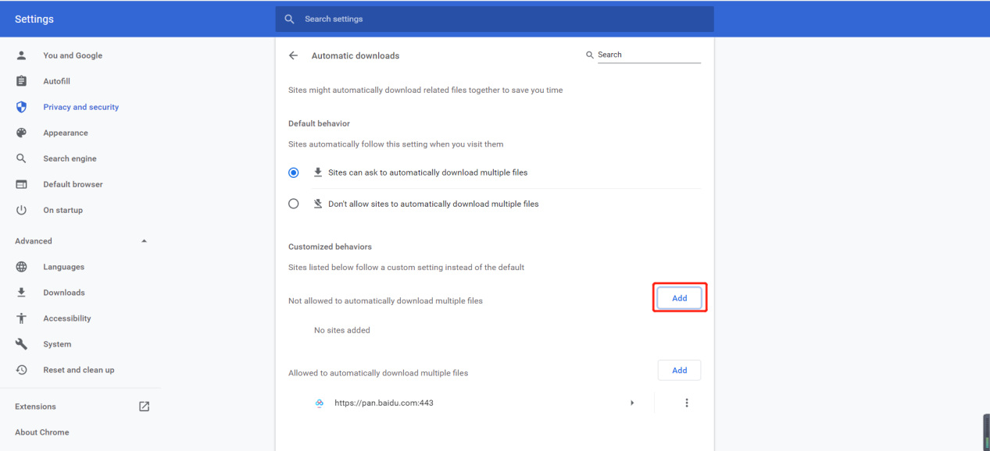

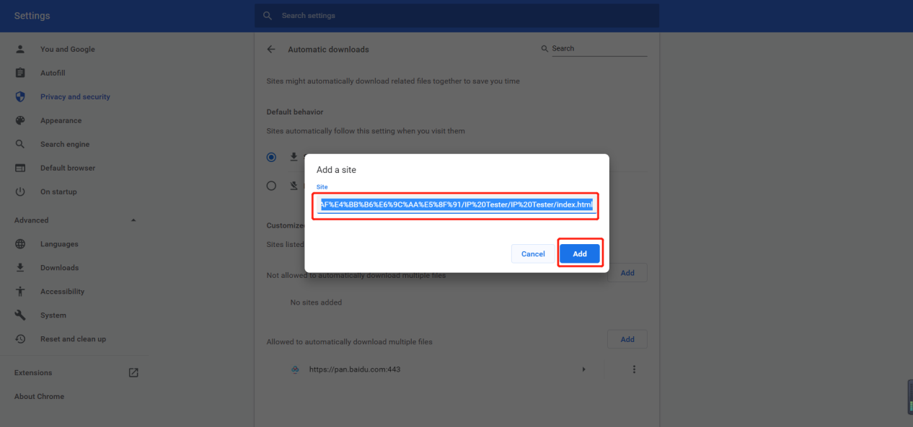

/*****Enable asking where to to save each file before downloading*****/

Settings-Advanced-Downloads-enable the option.

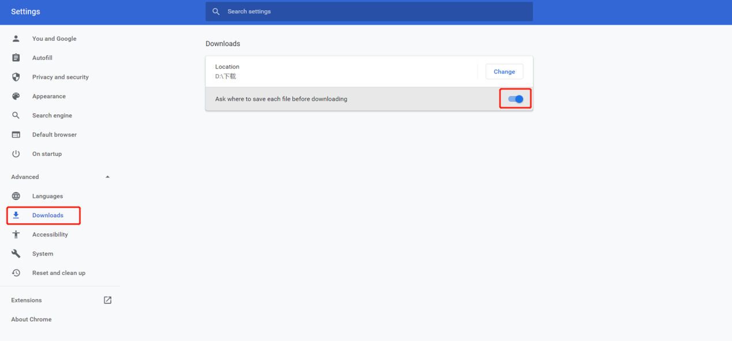

1. Access

Check if IP tester is properly connected with the PC. Open IP tester folder, double click index.html to open IP tester Web

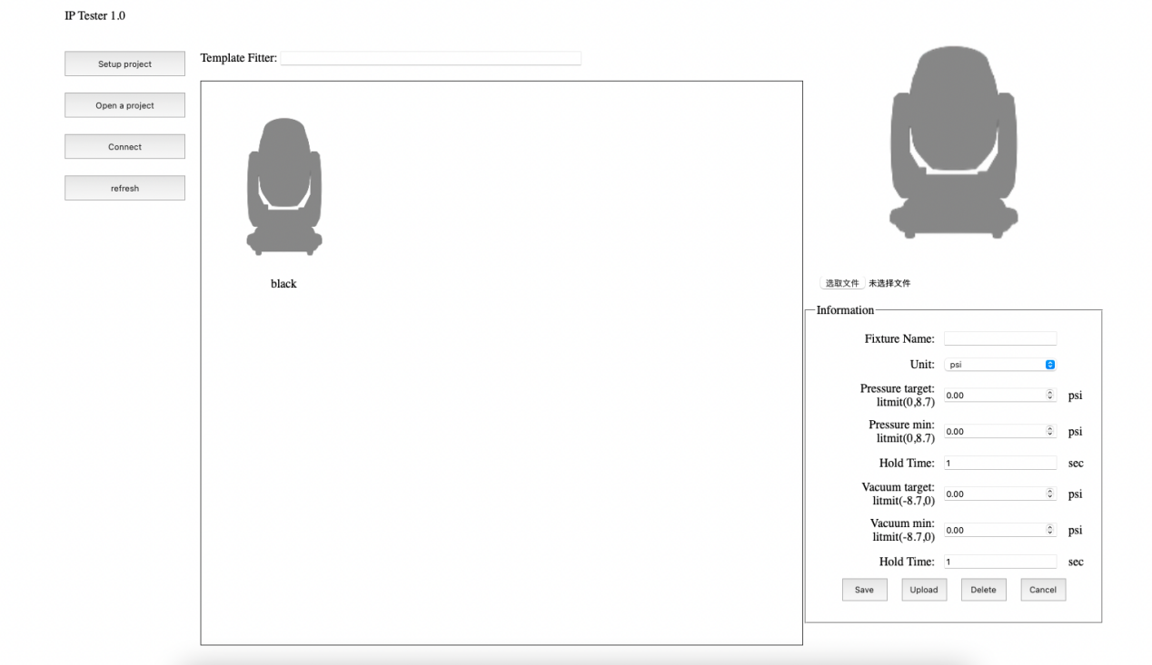

1. **IP Tester setting**

Click Connect button, connect the serial port. IP tester web will load the fixture personality in IP tester.

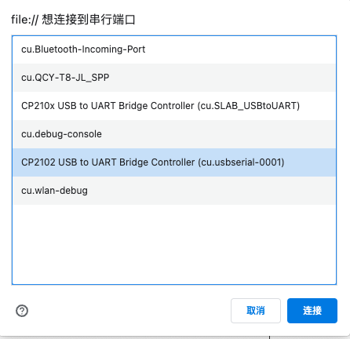

Setting：

**- Fixture name**: Enter fixture name

**- Unit**: Choose between kPa and psi.

**- Pressure target**: Enter maximum pressure value.

**- Pressure min**: Enter minimum pressure value.

**- Hold Time**: Enter time for Pressure test.

**- Vacuum target**: Enter maximum vacuum value.

**- Vacuum min**: Enter minimum vacuum value.

**- Hold Time**: Enter time for Vacuum test.

1. Add fixture personality：

Set all the values in information box, then press upload, the personality then is uploaded to IP tester.

1. Edit existing fixture personality：

Choose the personality you would like to edit, edit the setting in Information box, then press upload.

1. Delete fixture personality

Choose the personality, press delete

1. Import photo for personality

- import photo: Upload fixture photo in .png or .jpg format（recommended resolution 150*200 or 250*280）

Press choose file, choose the picture for the fixture. The picture will be saved to IP Test/pics folder. Please note that the file name of the picture must be same as the fixture personality. If the file name already exist, it will replace the old one. Press refresh after saving.

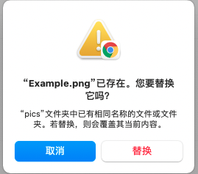

Note：Please delete the numbers created by the PC for existed file names. For example “Example(1)”=>”Example”.

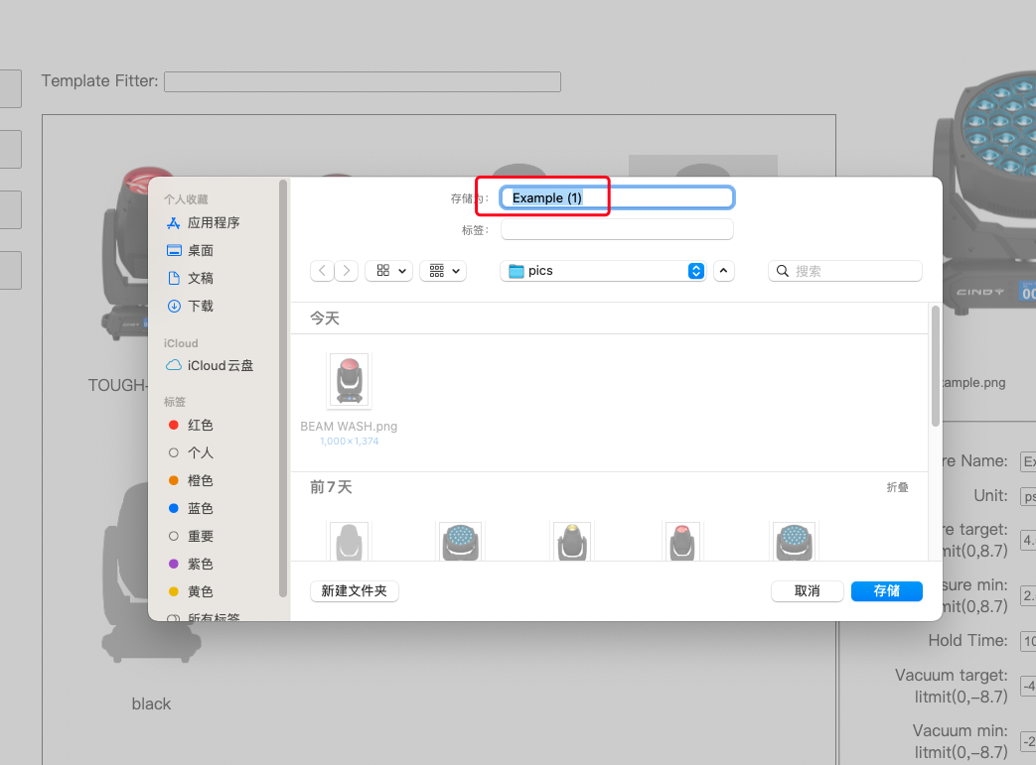

1. **IP Tester real-time test**

Press “Setup project”to enter.

Setting：

**Current pressure:** shows current fixture pressure.

**Hold time:** shows hold time for either Pressure test or Vacuum test.

**Main:** click here to return to main interface.

**Pressure:** click here to begin Pressure test.

**Vacuum:** click here to begin Vacuum test.

**Auto :** click here to performs Pressure test first, then Vacuum test.

1. Press “Pressure/Vacuum/Auto”to run test. The test result will show on the chart.

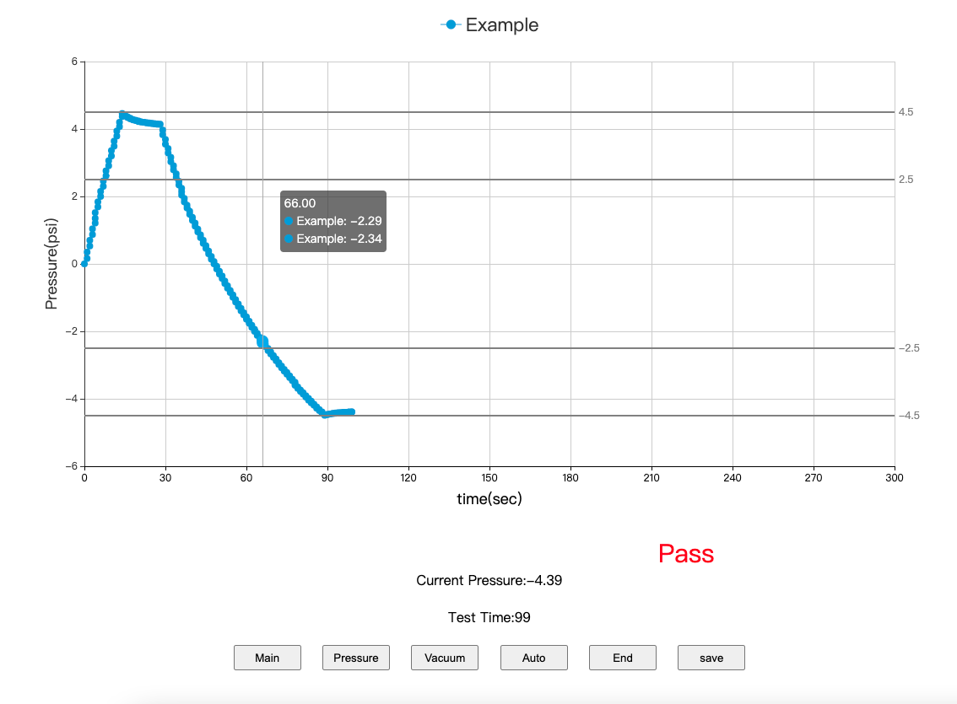

1. End:to end any running test.
2. Save: Press “save”will save result in json.and excel.files.When the browser pop up a window asking for permission to download multiple files, please press enable. In order to well organize the files, recommend to save the files in IP Tester/saveData.

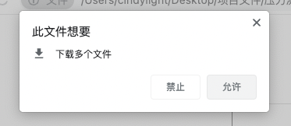

1. **Open files**
2. Open excel.file in excel

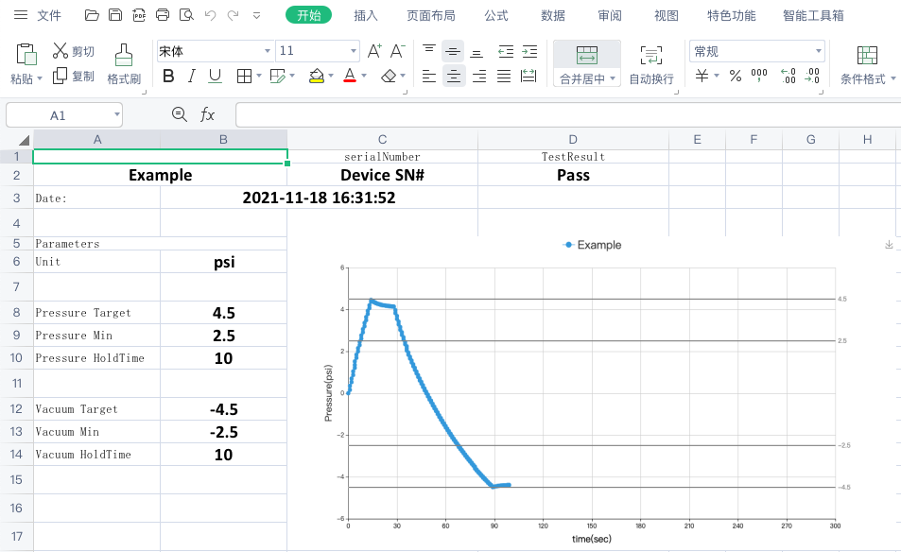

1. press“Open a project”in IP Tester web, choose the json. File you would like to open.

